Stutton Beach Clean
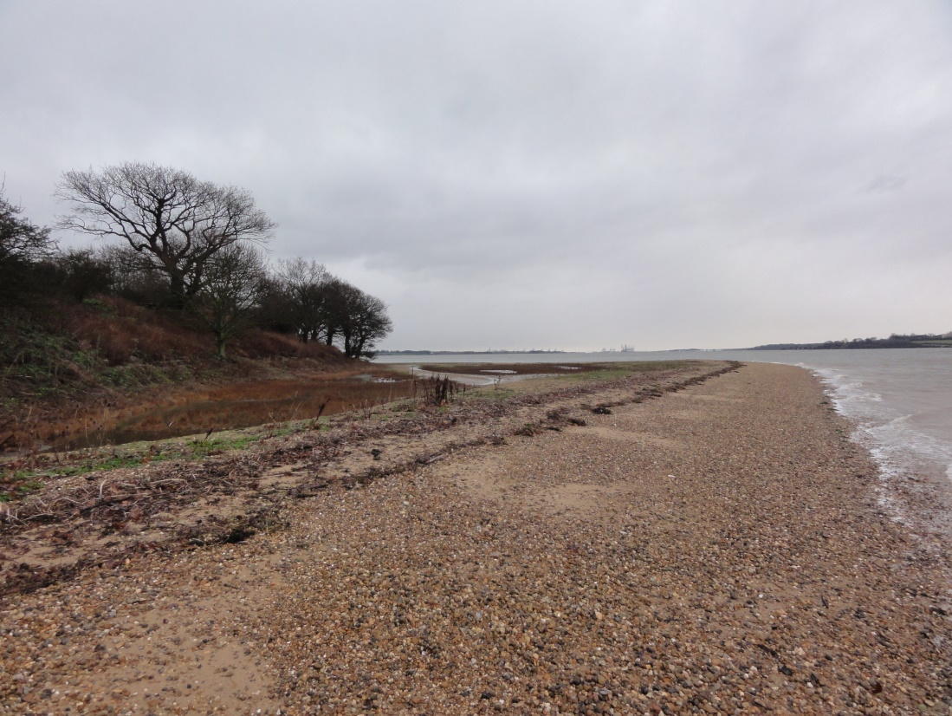
Annual Beach Clean on Saturday 25th September 2021
Meet 10.00am at Stutton point, pickers and bags will be provided
Please bring some gloves and drinks
For further info please ring me.
Please Book in before the day so we have contact details to:-
Chris Leach. phone 328939
Chris.j.leach@btinternet.com

